**TABLE OF CONTENTS**

TITLE PAGE

Approval Sheet

Acknowledgment

Abstract

Table of Contents

List of Table

List of Figures

**Chapter I**

**INTRODUCTION**

**Background of the Study**

Artificial Intelligence (AI) has brought about significant changes to various aspects of our lives, including the job market. The integration of AI algorithms in the development of the Alumni Tracker with Job Matching system has enabled job seekers to find personalized job recommendations based on their skills and qualifications. The objective of this research is to develop an AI-based Alumni Tracker with Job Matching system that will support alumni of the Northern Negros State College of Science and Technology (NONESCOST) in finding job opportunities that are a good fit for their skills and qualifications.

The Alumni Tracker with Job Matching using AI Integration system will collect and analyze data on alumni's education, work experience, skills, and preferences to provide personalized job recommendations. This system will help alumni stay informed about the latest trends in the job market by providing up-to-date information on job openings and the skills and qualifications required to succeed in those roles. Using AI algorithms, the system will match alumni with job openings that are a good fit, enabling employers to find qualified candidates for their job openings.

The development of the Alumni Tracker with Job Matching system using AI Integration highlights the commitment of NONESCOST to support its alumni in achieving success in their chosen careers. This system's innovative approach sets it apart from other alumni tracker systems that may rely on manual processes or limited data analysis. The personalized job recommendations and up-to-date information on job openings provided by the system are crucial features that will help alumni navigate the competitive job market and find opportunities that match their profile.

**Objectives of the Study**

**General Objective**

This study aims to develop an Alumni Tracker with Job Matching using AI Integration.

**Specifically, it aims to**

1. Design a system that manage data of NONESCOST Alumni that includes their education, work experience, skills, and job preferences.
2. Design a system that integrate AI:
   1. Job matching algorithm that can analyze alumni data and provide personalized job recommendations.
   2. Natural Language Processing (NLP) algorithm to analyze text and provide suggestions for improving grammar, punctuation, style, tone, and clarity.
   3. Optical Character Recognition to recognize printed or handwritten text in digital images or scanned documents.
3. Generate the following reports
   1. Alumni Report
   2. Employer Report
   3. Job Posting Report
4. Determine the quality of the developed system based on **ISO/IEC 25010:2011** Systems and Software Quality Requirements and Evaluation (SQuaRE) Quality Model

**Scope and Limitation**

The scope of this study is to develop an Alumni Tracker with Job Matching system using artificial intelligence (AI) to support the alumni of the Northern Negros State College of Science and Technology (NONESCOST) in finding job opportunities that match their skills and qualifications. The system will collect data on alumni's education, work experience, skills, and preferences to provide personalized job recommendations. The system will also integrate job postings to match alumni with job openings that are a good fit. The system's primary goal is to help alumni achieve success in their chosen careers by connecting them with job opportunities that meet their needs and qualifications.

The Alumni Tracker with Job Matching system has a few limitations that should be taken into account. Firstly, the system is dependent on the data provided by alumni, and if alumni do not provide accurate or up-to-date information, the system's effectiveness may be compromised. Secondly, the system's matching algorithms may not always provide perfect job matches, and it is the responsibility of the job seeker to evaluate the job opportunities presented by the system. Additionally, the system's effectiveness may be limited by the availability of job postings in the database, and it may not be able to capture all job opportunities in the job market. Finally, the system's effectiveness may be limited to the specific region or job market in which it is deployed, and its scalability to a wider range of job markets may require further research and development.

**Significance of the Study**

The NONESCOST Alumni Tracker with Job Matching using AI Integration system is designed to benefit several stakeholders, including NONESCOST alumni, employers, and the academic institution itself.

**NONESCOST Alumni**. The primary beneficiaries of the system are the alumni of the institution. The system will provide personalized job recommendations that match the alumni's education level, work experience, skills, and job preferences. The system will help alumni find job opportunities that align with their career goals, increasing their chances of finding employment that matches their interests and skillset.

**Employers.** The system will benefit employers by providing a pool of qualified job applicants who match their job requirements. Employers will benefit from a more efficient recruitment process, reducing the time and resources required to find suitable candidates. The system will help employers find qualified applicants who match their job requirements, increasing the likelihood of successful job placements.

**Academic Institution.** The system will benefit the academic institution by improving its alumni engagement and support services. By providing a job matching service for alumni, the institution can enhance its reputation and improve its relationships with alumni. The system will also provide valuable data on alumni employment trends, which can be used to improve the institution's academic programs and curriculum.

**Future Researchers.** The project may serve as a reference for future researchers.

**Definition of Terms**

**AI Integration**: Conceptually, AI integration refers to the use of artificial intelligence algorithms and techniques to enhance the performance and capabilities of a system. Operationally, AI integration in the NONESCOST Alumni Tracker system refers to the use of machine learning algorithms to analyze alumni data and provide personalized job recommendations.

**Job Matching**: Conceptually, job matching refers to the process of matching job seekers with suitable job opportunities based on their skills, education, work experience, and job preferences. Operationally, job matching in the NONESCOST Alumni Tracker system refers to the algorithmic process of analyzing alumni data and employer job requirements to identify suitable job opportunities for alumni.

**Alumni Tracker:** Conceptually, an alumni tracker refers to a system that tracks the academic and employment progress of alumni. Operationally, the Alumni Tracker in the NONESCOST system refers to the database and user interface that enables alumni to input and update their personal and employment information, which is used by the job matching algorithm to provide personalized job recommendations.

**Data Analytics:** Conceptually, data analytics refers to the process of analyzing and interpreting data to derive insights and make informed decisions. Operationally, data analytics in the NONESCOST Alumni Tracker system refers to the use of machine learning algorithms to analyze alumni data and employer job requirements to provide personalized job recommendations.

**Personalized Job Recommendations:** Conceptually, personalized job recommendations refer to job opportunities that match the job seeker's skills, education, work experience, and job preferences. Operationally, personalized job recommendations in the NONESCOST Alumni Tracker system refer to the algorithmic process of analyzing alumni data and employer job requirements to identify suitable job opportunities for alumni.

**Conceptual Framework**

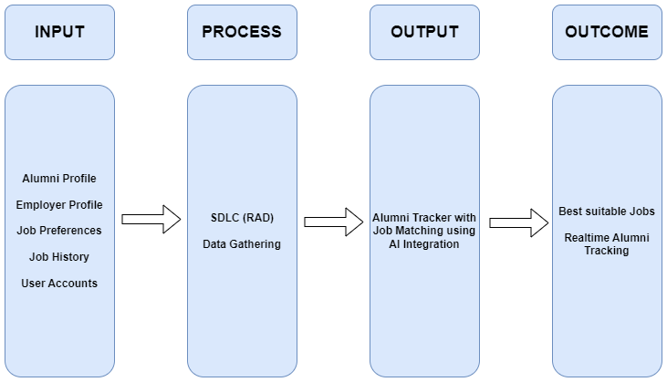

**Figure 1. Conceptual Framework of the Study**

Figure 1 shows the NONESCOST Alumni Tracker with Job Matching system that uses AI integration to match alumni with job openings. The system is based on the IPOO model and enables employers to find qualified candidates for their job openings while also providing real-time tracking of NONESCOST alumni. In summary, it is a tool that simplifies the job matching process and enhances the tracking of alumni.

**Chapter II**

**RELATED LITERATURE AND PRIOR ARTS SEARCH**

**Related Literatures**

**ALUMNI TRACKING SYSTEM [1]**

The study proposes an online-based application, the Alumni Tracking System, to enhance the current tracking process of college graduates. The system provides a centralized platform for the management of alumni data and facilitates communication between alumni and the institution. The proposed system offers great advantages to the alumni, such as reducing maintenance effort and providing an all-in-one solution for collecting and managing alumni data.

**An Alumni Portal and Tracking System [2]**

The paper describes a web-based alumni tracking system that aims to manage alumni data and provide a platform for alumni to update their information and view online yearbooks. The study presents insights from alumni responses, including job positions, employers, current location, and further education preferences. The system has been effective in managing alumni data and has been accessed by many alumni, highlighting the importance of an efficient alumni tracking system for institutions.

**Design and Development of Alumni Tracking Information System [3]**

The study developed and evaluated a web-based alumni tracking information system for SMKN 1 Garut using a waterfall model and functional testing. The system was found to be feasible and received a positive response from alumni users. The research highlights the importance of implementing an efficient alumni tracking system and the benefits of a web-based platform for managing alumni data.

**Design and Development of Alumni Tracking System for Public and Private HEIs [4]**

This study aimed to develop an alumni tracing system that would allow the University to track its graduates using the internet, providing important information such as their employment status and essential skills required for their current job. The system can generate comprehensive reports for planning, program implementation, and decision-making purposes. This study emphasizes the importance of an efficient alumni tracking system in providing feedback to HEIs to improve their curriculum and ensure that it meets the needs of the industry.

**Centralized Alumni Management System (CAMS) - A Prototype Proposal [5]**

The paper proposes a centralized system for alumni management that focuses on alumni networks across institutions and organizations, with a fundamental goal of promoting mentorship processes within and across institutions. The system allows individuals to register as alumni not only after graduation but also while still in school, thereby facilitating networking among professionals and students. The proposed system offers several benefits to both alumni and institutions/organizations and exhibits superior features compared to existing proposals.

**Alumni Social Networking Site [6]**

The objective of this project is to build an alumni website and social networking site that establishes a link between the present students and the alumnae of the institute. The website will provide a user-friendly interface that facilitates the user to understand the working of the site easily, allowing them to register or sign up, log in to their timelines and interact with other users by sharing ideas, digital photos and videos, posts, personally chat, and inform others about online or real-world activities and events. The main goal of the project is to create a platform that helps institutions keep track of their alumni and provide friendly guidance to the students regarding their career.

**Alumni Database Management System [7]**

The main objective of this project is to build a system for managing alumni data and creating interaction between alumni, admin, and students of a college. The system will provide easy access to alumni data and allow communication between students and alumni with admin permission. Final year students will have access to the system using a student login ID, which can help them build connections for their projects or placements. The system will also automatically transfer student data to the alumni module upon graduation.

**Alumni Interactive System Using Mining [8]**

The study proposes the use of data mining algorithms in university alumni systems to enhance mentoring between alumni and current students. The aim is to promote ongoing relationships between graduates and their alma mater, and to provide a platform for students to interact with alumni for career and business opportunities. The proposed system uses basic data mining algorithms to make it more interactive and user-friendly.

**The Alumni Information Management Model Based on "Internet +”.[9]**

This paper proposes an intelligent integrated alumni information management system framework that combines online and offline approaches to address the existing problems in alumni management such as fragmentation of alumni information and time, delay in information transmission, and simplification of management system function. The proposed framework includes three modules: "Alumni Social Network," "Intelligent Data Acquisition and Storage," and "Data Mining and Decision-Making Support," and aims to build a social platform for alumni network while using intelligent technology to collect and store massive alumni data and datamining technology to improve decision-making for talent training schemes. The system is designed to leverage "Internet+" to enhance alumni management work.

**Designing Mobile Alumni Tracer Study System Using Waterfall Method: an Android Based. [10]**

This study aims to develop an Android application for tracking alumni of the Industrial Engineering Department at UPN Veteran Yogyakarta, Indonesia, due to the lack of systematic compilation and minimal alumni data. The research methodology used is qualitative descriptive with a prototyping system development method, and data is collected through interviews and observation. The expected results of this study include an Android application for alumni search, analysis of alumni data obtained, and a survey approach to describe graduates' profiles and the relevance of the Industrial Engineering Study Program curriculum.

**ATS ANALYSIS, DESIGN AND DEVELOPMENT OF THE ALUMNI TRACKING SYSTEM OF THE LICERIO ANTIPORDA SR. NATIONAL HIGH SCHOOL-DALAYA EXTENSION [11]**

The purpose of this study was to design and develop a software platform for tracking alumni at Licerio Antiporda Sr. National High School- Dalaya Extension. The study identified the problems and challenges with the existing manual tracking system and implemented an online Alumni Tracking System to address these issues. The developed system is a potential technological tool in tracking alumni and can contribute to the management program development while reflecting on the status of its alumni.

**DIGITAL SKILL: OPTIMIZING THE UTILIZATION OF INFORMATION TECHNOLOGY BY PESANTREN UNIVERSITY IN ALUMNI TRACKING ACTIVITIES [12]**

This research aims to explore the implementation of a tracer study at Universitas Darussalam Gontor by optimizing information technology and using a website-based alumni tracking system. The study utilized a qualitative case study approach and data was collected through interviews and observations. The results showed that the tracer study had optimized the use of information technology in the form of a google form and a website-based alumni tracking system was being developed, while recommendations were made for increasing skills and knowledge for optimizing the use of the website-based system.

[**A LinkedIn Analysis of Career Paths of Information Systems Alumni**](https://aisel.aisnet.org/cgi/viewcontent.cgi?article=1007&context=jsais) **[13]**

This study examines the extent to which LinkedIn profiles can provide a more realistic picture of entry-level jobs held by Information Systems program alumni and their subsequent career progress. The investigation used information from 175 graduates of the program at a mid-sized comprehensive university in the southeastern USA, and suggests that LinkedIn profiles can be used to assess long-term outcomes of IS programs, answer questions about career paths for IS professionals, and evaluate the transition from technical to managerial positions.

**An Alumni Tracer System for Saint Louis College [14]**

The aim of this study was to develop an Alumni Tracer System for Saint Louis College using the Software Engineering Process. The developed system was tested for usability by IT experts using the WUCET test and by the Alumni Affairs and Job Placement Officer and selected alumni using the WAMMI tool, and was found to have a high level of usability, addressing the constraints of the existing Alumni Tracer System. The study recommends the adoption of the developed Alumni Tracer System by Saint Louis College.

**Tracer Study as an Effort to Improve Alumni Careers in Kadiri University Job Placement Service.[15]**

The purpose of this quantitative descriptive study with a cross-sectional approach is to investigate the transition of graduates from education to the world of work, alumni assessment of higher education's contribution to obtaining competencies, and vertical and horizontal alignment felt by alumni. The target population is 2419, with a total of 955 contactable alumni, and 195 alumni responded to the questionnaire. The findings suggest that alumni take an average of six months to secure a job, with most job searches done through personal connections, and private companies are the most common type of workplace. Additionally, the majority of respondents felt that their competencies were vertically and horizontally aligned.

**Web-Based Abulyatama Alumni Information System [16]**

The purpose of this research project is to develop a web-based E-Tracer study service for STMIK Abulyatama to improve the existing manual system for collecting data on alumni. The objectives of the research are to analyze the alumni information system, design and develop the alumni management information system, and improve the existing system for better performance in alumni data collection. The proposed system is expected to provide more accurate and up-to-date information about alumni, simplify and speed up administrative processes, and benefit curriculum improvements.

**Developing a Tracer Study Information System Based on SMS Gateway to Support Career Development Program in UPI, Cibiru Campus.[17]**

The purpose of this research is to design an information system based on SMS Gateway technology to provide job-related information to UPI Kampus Cibiru graduates quickly and sustainably in accordance with their scientific fields. The Rapid Application Development method is used in this study to design the system, which is built using HTML Programming Language, PHP, and Bootstrap as a CSS framework. The proposed system is expected to improve the absorption of UPI Kampus Cibiru graduates in the working environment and serve as an indicator of the institution's success in organizing the educational process.

**Dashboard-based Alumni Tracer Study Report Using Normalized Data Store Architecture.[18]**

This research aims to develop a data warehouse using the NDS architecture for alumni monitoring at Universitas Muhammadiyah Yogyakarta. The study found some noise in the data, such as null data and duplication of data, which were cleaned during the process. The data warehouse met the institution's requirements and was displayed in a report that was easier to analyze, and the report was made into a dashboard form using the Power BI application.

**E-tracer study implementation of Indonesia Computer University alumni.[19]**

This study describes the tracer study conducted by Indonesia Computer University in 2016 for its 2014 graduates using an online survey through various communication channels. The research focuses on the response rate and alumni characteristics, such as their transition period, job relevance, and competence. The results show a 28% response rate, a median transition period of four months, and a zero competence gap in research skills, indicating the university's success in achieving its graduates' aim in this area.

**Development of Industry Academe Linkage Alumni and Placement Portal.[20]**

The study aimed to develop an Industry Academe Linkage Alumni and Placement Portal for FEU Institute of Technology, which would automate the workflow and processes of interns for industry placement and tracking of alumni. The study employed the Incremental Model Process as the software process model and the ISO 9126 for determining the acceptability of the developed prototype based on criteria such as functionality, usability, reliability, portability, and supportability. The overall evaluation of the system is 4.21, indicating that the application is satisfactory and ready for deployment.

**Prior Arts**

**A career counseling system based on intelligent matching algorithms.[21]**

This paper describes a career counseling system that uses intelligent matching algorithms to help individuals find suitable job opportunities based on their skills and interests.

**A job matching system based on ontology and machine learning.[22]**

This article presents a job matching system that uses ontology and machine learning to match job seekers with suitable job opportunities based on their skills and qualifications.

**A job recommendation system based on multi-criteria decision making [23]**

This paper proposes a job recommendation system that uses multi-criteria decision making to recommend job opportunities based on the preferences and qualifications of job seekers.

**A method for using natural language processing to match job seekers with suitable job postings.[24]**

This article describes a method for using natural language processing to match job seekers with suitable job postings based on their skills and qualifications.

**An intelligent job matching system based on deep learning.[25]**

This paper proposes an intelligent job matching system that uses deep learning algorithms to match job seekers with suitable job opportunities based on their skills and qualifications.

**A hybrid approach for job recommendation using collaborative filtering and content-based filtering.[26]**

This article presents a hybrid approach for job recommendation that combines collaborative filtering and content-based filtering to recommend job opportunities based on the preferences and qualifications of job seekers.

**A job matching model based on artificial neural network.[27]**

This paper proposes a job matching model that uses artificial neural networks to match job seekers with suitable job opportunities based on their skills and qualifications.

**Job matching based on ontology and semantic matching.[28]**

This article presents a job matching approach that uses ontology and semantic matching to match job seekers with suitable job opportunities based on their skills and qualifications.

**Job matching system based on personality traits and skills.[29]**

This paper proposes a job matching system that uses personality traits and skills to match job seekers with suitable job opportunities.

**Predicting career outcomes using natural language processing and machine learning [30]**

This study uses natural language processing and machine learning to analyze alumni career data and predict future career outcomes.

**Intelligent career counseling system using data mining techniques [31]**

This study proposes an intelligent career counseling system that uses data mining techniques to match job seekers with suitable careers.

**A hybrid intelligent system for job matching and career recommendation [32]**

This study proposes a hybrid intelligent system that combines fuzzy logic, case-based reasoning, and genetic algorithms to match job seekers with suitable careers.

**Development of an intelligent career counseling system using association rule mining [33]**

This study proposes an intelligent career counseling system that uses association rule mining to match job seekers with suitable careers.

**Job recommendation system using machine learning algorithms [34]**

This study proposes a job recommendation system that uses machine learning algorithms to match job seekers with suitable job opportunities.

**A fuzzy logic-based intelligent job matching system [35]**

This study proposes an intelligent job matching system that uses fuzzy logic to match job seekers with suitable job opportunities.

**Intelligent career path recommendation system using machine learning algorithms [36]**

This study proposes an intelligent career path recommendation system that uses machine learning algorithms to recommend suitable career paths for job seekers.

**A career guidance system based on clustering analysis [37]**

This study proposes a career guidance system that uses clustering analysis to match job seekers with suitable careers.

**An intelligent job matching system using rule-based reasoning [38]**

This study proposes an intelligent job matching system that uses rule-based reasoning to match job seekers with suitable job opportunities.

**A semantic approach to job matching [39]**

This study proposes a semantic approach to job matching that uses ontologies to match job seekers with suitable job opportunities.

**A web-based intelligent job recommendation system using collaborative filtering [40]**

This study proposes a web-based intelligent job recommendation system that uses collaborative filtering to match job seekers with suitable job opportunities.

**Synthesis**

Based on the related literature and prior arts, it is evident that there is a growing need for job matching systems that can help alumni find suitable job opportunities based on their skills, qualifications, and preferences. These systems often use intelligent algorithms, such as machine learning and natural language processing, to match alumni job seekers with job postings that meet their criteria.

**Chapter III**

**METHODOLOGY**

**System Design**

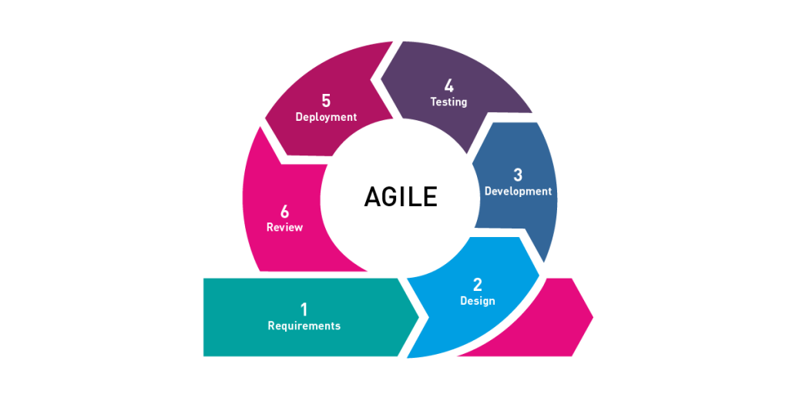

**Figure 2. Agile Software Development**

The **Agile** methodology is a software development approach that emphasizes collaboration, flexibility, and continuous improvement. It focuses on delivering value to end-users through rapid iteration and incremental development. The Agile methodology is based on the Agile Manifesto, a set of values and principles for software development that prioritize individuals and interactions, working software, customer collaboration, and responding to change.

**Software Life Cycle Model**

**Planning**: In this phase, the development team works with stakeholders to define the project scope, establish goals and objectives, identify risks and challenges, and determine the initial requirements for the system. The team creates a roadmap that outlines the development process, timelines, and milestones.

**Design**: In this phase, the development team creates a high-level design for the system, which includes the system architecture, technology stack, database design, and user interface. The team also defines the functionality of the system and how it will be implemented.

**Development**: In this phase, the development team begins building the system by creating software components, integrating them, and testing them. The team works in short iterations, which typically last 2-4 weeks, to deliver a working system incrementally.

**Testing**: In this phase, the development team tests the system to ensure that it meets the requirements and is functioning as expected. Testing is done throughout the development process, with each iteration being tested thoroughly before moving to the next one.

**Deployment**: In this phase, the development team deploys the system to a test environment or a staging server for further testing and feedback. Once the system is fully tested, it is deployed to the production environment.

**Maintenance**: In this phase, the development team continues to maintain and improve the system, fixing any bugs or issues that arise, adding new features, and updating the system to keep up with changing requirements or technologies.

**Context Flow Diagram**

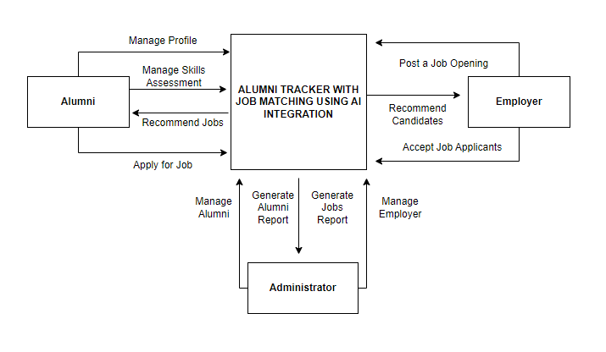

**Figure 3. Context Flow Diagram**

Figure 3 shows how the researcher maps out on how the entire features and components of the system will work together according to its purpose.

**Data Flow Diagram**

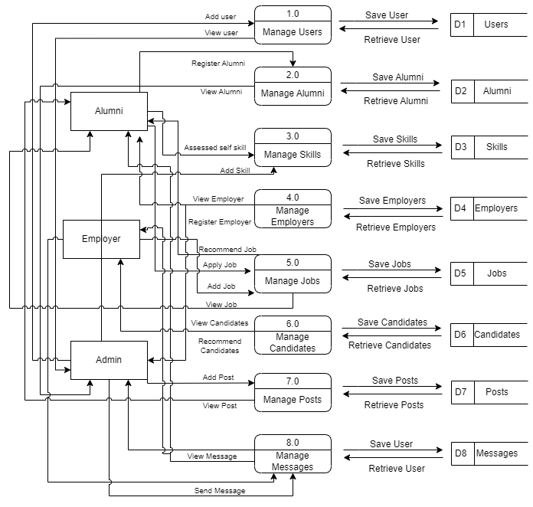

**Figure 4. Data Flow Diagram**

Figure 4 illustrates how information is processed within the system, including where it comes from, how it is transformed, and where it is stored. The purpose of the Data Flow Diagram is to depict the system's scope and boundaries, and it can be used as a tool for communication between the systems analyst and stakeholders involved in the system's redesign.

**Entity-Relationship Diagram**

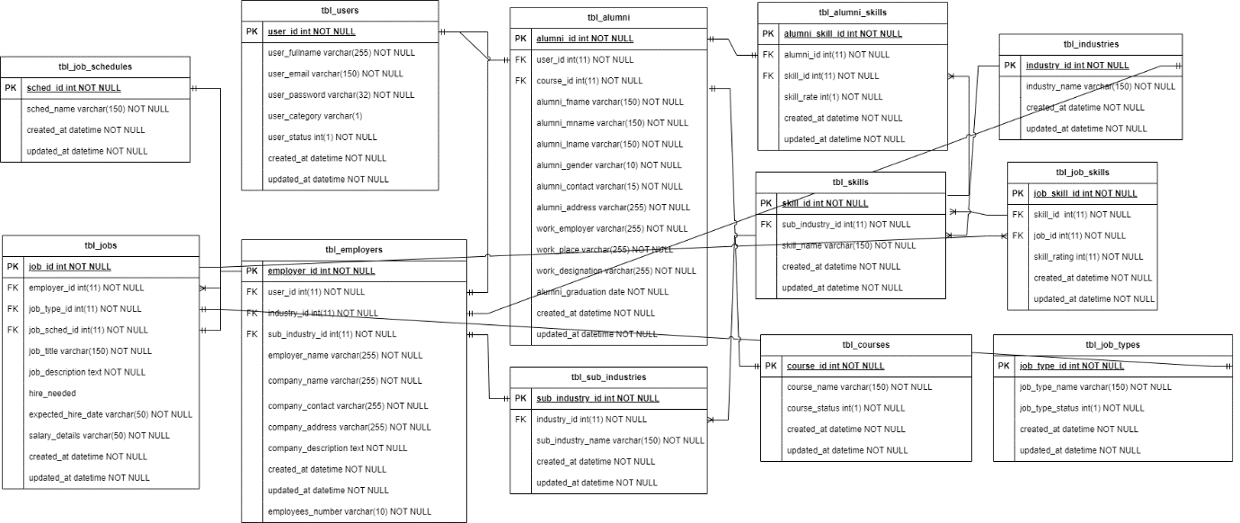

**Figure 5. Entity Relationship Diagram**

An entity relationship diagram gives a snapshot of how these entities relate to each other. You could call it the blueprint that underpins your system architecture, offering a visual representation of the relationships between different sets of data (entities).

**Application Architecture**

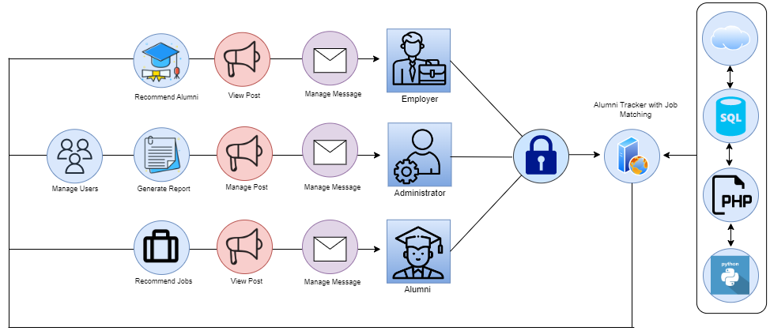

**Figure 6. Application Architecture**

Figure 6 shows how the system will work when used by the registered users.

**Use-Case Diagram**

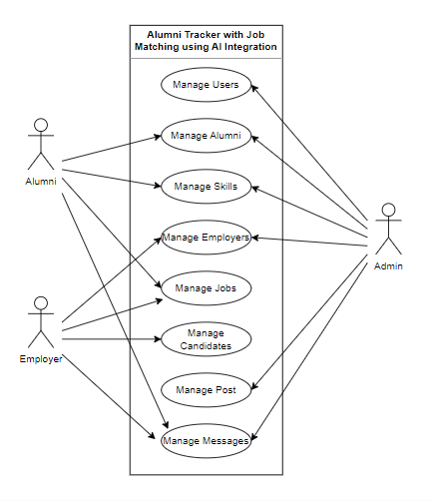

**Figure 7. Use Case Diagram**

A Use Case diagram is a representation of a user's interaction with the system that shows the relationship between the user and the different use cases in which the user is involved as shown in figure 7.

**Software Requirements**

Admin side:

Operating System (Windows 7,8 or 10)

PHP

Web Hosting/Server

MySQL

Python

Client side:

Operating System (Windows 7, 8, or 10)

Web browser

**Hardware and Other Required Devices**

Processor: Intel Core i3 or higher

RAM: 2GB or higher

Hard Disk Drive: 500GB or higher

Printer

Internet Plan at least 5 Mbps

**Cost-Benefit Analysis**

**Table 3.0**

**Developmental Cost**

|  |  |  |  |
| --- | --- | --- | --- |
| **Development Cost** | **Duration** | **Cost** | **Total Amount** |
| Programmer | 2 months | 20,000 | 20,000 |
| System Analyst | 2 months | 20,000 | 20,000 |
| AI Expert | 2 months | 30,000 | 30,000 |
| Computer set 3 |  | 20,000 | 60,000 |
| Internet Fee | 2 months | 1,299 | 2,598 |
| **Subtotal** |  |  | 132,598 |

Table 3.0 shows the developmental cost of the system that includes programmer fee, system analyst fee, AI Expert, cost of computer set, and internet fee which accumulated to 132,598.

**Table 4.0**

**Operational Cost**

|  |  |  |  |
| --- | --- | --- | --- |
| **Operational Cost** | **Duration** | **Cost** | **Total Amount** |
| Electrical Expense | 12 months | 1,000 | 12,000 |
| Internet Fee | 12 months | 1,299 | 15,588 |
| Maintenance Fee | 12 months | 1,500 | 18,000 |
| Cloud server (Hostinger VPS Server Plan 4) | 12 months | 1,629 per month | 19,548 |
| Computer set |  | 20,000 | 20,000 |
| Printer |  | 5,000 | 5,000 |
| **Subtotal** |  |  | **90,136** |

Table 4.0 shows the operational cost of the system that includes electrical expenses, internet fees, maintenance fee, cloud server, computer sets, and printers of alumni administrator which accumulated to 90,136.

**Table 5.0**

**Total Developmental and Operational Cost**

|  |  |
| --- | --- |
|  | **Total Cost** |
| Developmental Cost | 132,598 |
| Operational Cost | 90,136 |
| **Total** | **222,734** |

Table 5.0 shows the total developmental and operational cost of 222,734.

**Table 6.0**

**Benefits of the system**

|  |  |  |  |
| --- | --- | --- | --- |
| **Benefits of the system** | **Duration** | **Cost** | **Total Amount** |
| Improved Job Matching | 12 months | 9,000 | 108,000 |
| Increased Alumni Engagement | 12 months | 6,000 | 72,000 |
| Improved Career Outcomes | 12 months | 8,000 | 96,000 |
| Security of data | 12 months | 3,000 | 36,000 |
| Data backup | 12 months | 4,000 | 48,000 |
| **Total cost benefit** |  |  | **360,000** |

Table 6.0 shows the total cost benefit of the system that includes improved job matching, increased alumni engagement, improved career outcomes, security of data, and data backup which accumulated to 360,000.